AMEND
Tyler House
58-66 Morley Road
Tonbridge
Kent
TN9 1RA

Tel/Fax: 01892 516076

email: jo.grey@amend.org.uk
www.amend.org.uk
Informing & Supporting Families with M.E.N.
& Associated Endocrine Syndromes & Tumours

Tuesday 19th July, 2022

Dear Friend of AMEND

This year, The Association for Multiple Endocrine Neoplasia Disorders (AMEND) has applied to take part in the 2022 Big Give Christmas Challenge, the UK’s biggest online match funding campaign. In 2016 we managed to raise over £8,000 to fund the development of our resources for young adults. This year we’re raising vital funds to continue to provide a free, professional Counselling Service to our families affected by rare endocrine conditions where dealing with diagnosis, symptoms and treatment all have a major impact on mental health in our community.

About our Counselling Service
In 2021, our Counselling service provided 205 free Counselling sessions to 24 members of AMEND, ACC Support UK and Phaeo Para Support UK. Currently, due to the cost of the service, sessions are limited, but we would like to increase capacity since, as our membership increases, so does demand. 90% of users found the counselling ‘very helpful’ and the remaining 10% found it ‘moderately helpful’. The service is provided by rareminds CIC, who specialise in psychological support in rare disease settings. 100% of users chose our Counselling Service because it was specialised.

About The Big Give Christmas Challenge Pledges
As part of our Big Give application, we need our key supporters to make promises of funding, called ‘pledges’ which will be used as match funds to double online donations made to our charity during the public campaign. You would be required to fulfil this pledge i.e., pay it to us, after the campaign finishes on 6th December (and before 16th January 2023) depending on how successful we are at using up these matching funds. Your commitment of funding might also help us to secure additional match funds via a Champion (sourced by the Big Give).

We are aiming to raise a total of £3,900 in pledges to take part in the Christmas Challenge. Would you consider making a pledge of £100 or more to help us reach our target?

If you would be willing to make a pledge to us, or know someone who would, you and/or they can do so by completing this online form by the deadline of 23:59 on Friday 2nd September 2022:

https://www.thebiggive.org.uk/s/pledge?campaignId=a056900002M4zNwAAJ
YOU DO NOT NEED TO PAY ANYTHING NOW – SIMPLY MAKE A PLEDGE

What is the Christmas Challenge?
The Christmas Challenge (the UK’s biggest online match-funding campaign) helps UK-registered charities to raise funds for their projects by doubling donations when the campaign goes live on 29th November until 6th December. For example, a £100 online donation made to a participating charity during the Christmas Challenge can be doubled to become £200.

The match funds
The matching pots used to double donations for charities taking part in the Christmas Challenge are made up of a combination of funds. These are funds sourced by the charity (‘Pledges’) and funds sourced by the Big Give (‘Champions’) which are available if we are successfully selected by a Champion. We can still take part in the Christmas Challenge even if we are not selected by a Champion. Pledge funds and Champion funds (if selected by one) combine to form the matching pot and are used to double donations. Donations are matched by our Pledge funds until these are exhausted and then donations are doubled by Champion funds. You can watch a short video explaining how it works at www.thebiggive.org.uk/christmas-challenge/.

How would it work for you?
As a Pledger, you commit a Pledge promise to our matching pot. Your funds will be used to match online donations when the campaign goes live. Research shows that 84% of donors are more likely to give in a match funding campaign and that donations are on average 2½ times bigger. By committing a Pledge promise you will help us to inspire donors to support AMEND.

If we are selected for Champion funding, your Pledge promise could be worth up to four times its initial value once it’s added to the Champion funds and online donations. This makes the Christmas Challenge one of the most attractive times to make a contribution to AMEND.

What is the benefit for you?
People and companies who Pledge to AMEND’s campaign will be listed together with logo where appropriate on our special webpage and will be mentioned wherever possible in any publicity generated.

Additional information
- In December we will let you know the outcome of the Christmas Challenge and ask you to fulfil your Pledge promise. The timeline for fulfilling the pledge (i.e., transferring the funds to us) is from 7th December 2022 until 16th January 2023.
- Please note that your pledge is being used to match online donations from the public - this means that fulfilment of your pledge is conditional on us receiving the appropriate online donations during the campaign (29th November – 6th December). You will only be required to pay a pro-rata amount of your pledge if we don’t hit our online target - it's our guarantee to you that we are committed to raising additional donations.
- Please note that if you pledge to AMEND, you will not be able to make an online donation to us in December because your pledge will be used to match these donations.

You can find full details of the Christmas Challenge, and how your pledge will enable us to be part of the UK's largest Matched Funding Challenge, on the Big Give website (www.thebiggive.org.uk).

Please don’t hesitate to ask if you have questions about the Christmas Challenge and what being a Pledger could mean to AMEND
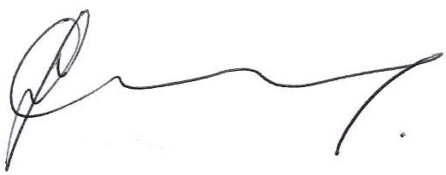
Mrs Jo Grey
AMEND CEO

Remember: If you would be willing to make a pledge to us, or know someone who would, you and/or they can do so by completing this online form by the deadline of 23:59 on Friday 2nd September 2022:

https://www.thebiggive.org.uk/s/pledge?campaignId=a056900002M4zNwAAJ
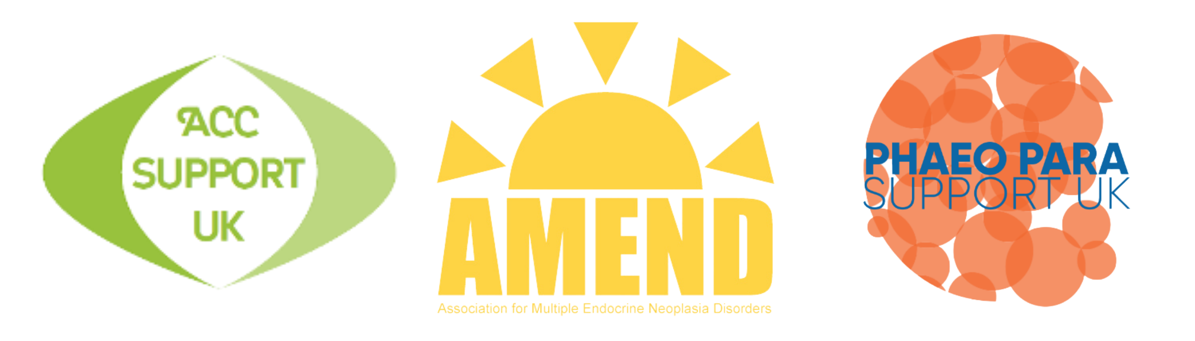YOU DO NOT NEED TO PAY ANYTHING NOW – SIMPLY MAKE A PLEDGE
HOW THE BIG GIVE MATCHED FUNDING WORKS

